**What is a Hybrid Mobile App?**

This solution is a blend, hence the name hybrid, of both native and web solutions. Where the core of the application is written using web technologies (HTML, CSS, and JavaScript), which are then encapsulated within a native application. Through the use of plugins, these applications can have full access to the mobile device’s features. To better understand this approach, let’s break down how it all fits together.

**HOW TO CREATE AN IONIC WEB APP .**

1. NODE JS
2. NPM

**STEPS FOR CREATING IONIC WEB APP.**

1. Install ionic using npm install -g ionic.
2. Get ionic info using ionic info.
3. To create an ionic app type ionic start <app name>.
4. Then it will ask to choose a framework if you want to make it in angular thenchoose angular.
5. Then to start running the ionic web page in the server type ionic serve

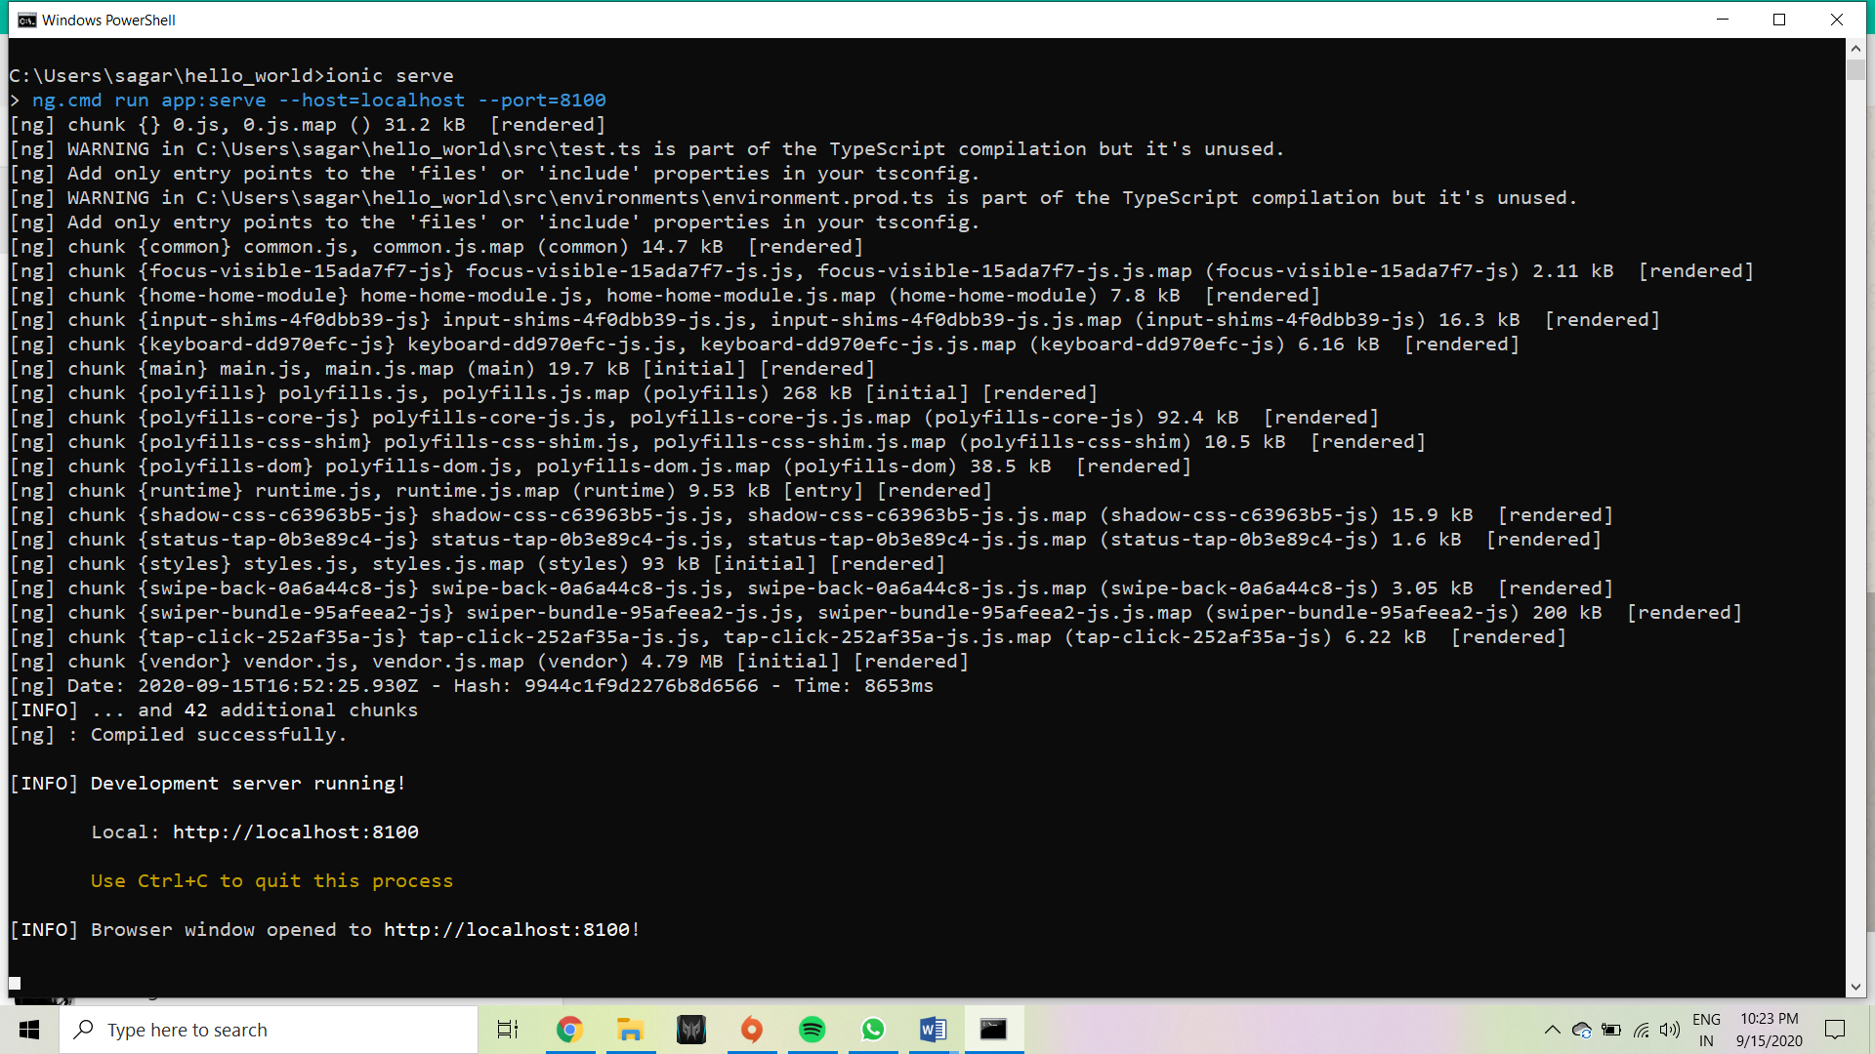

1. To access the web page go on http://localhost:8100

FINAL OUTPUT:

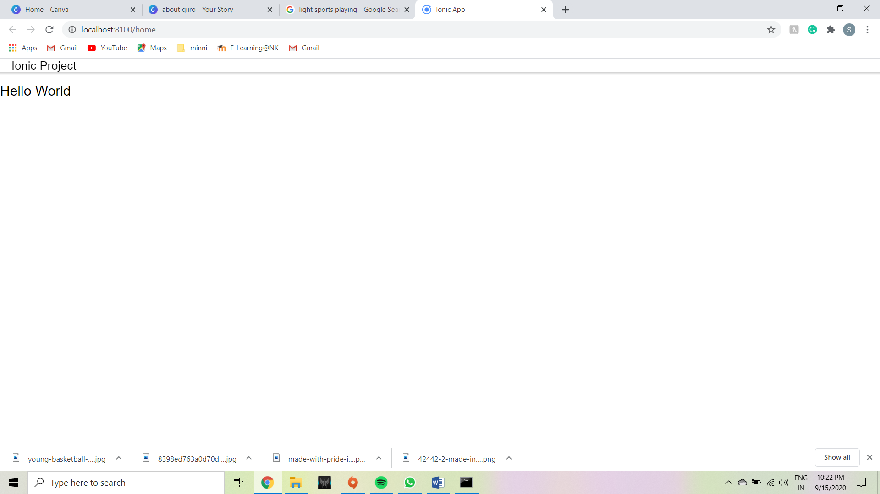

## How to create and Ionic Android app:

## STEPS FOR CREATING AN IONIC ANDROID APP.

### After you have built the web app next command you should type is ionic cordova platform add android .This will add and android platform to your web app directory.

### Now type ionic cordova build android to start building your android app.

### 3. Now type ionic cordova run android , If you have connect your machine to a phone and turned on USB debugging the app will export to your pc and if you are running an emulator the out will be like this.

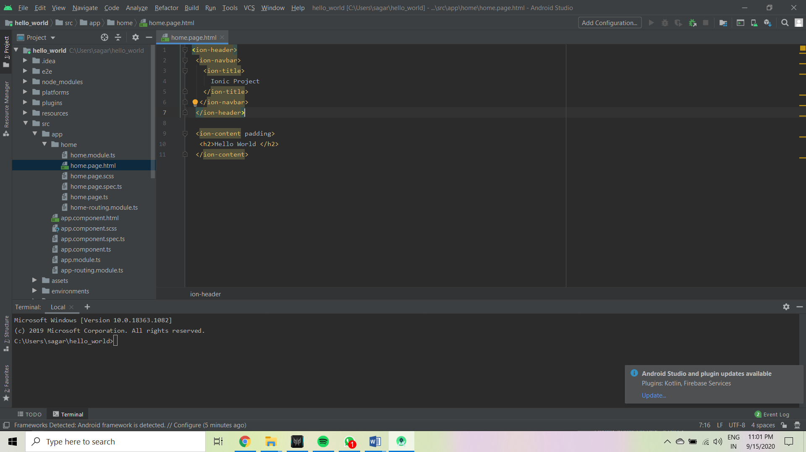

**FINAL OUTPUT:**

